**Name - Divyani Khade**

**Batch - 6th Feb Python Fullstack with Data Science**

**Date - 23rd April, 2025**

1. **Output -**

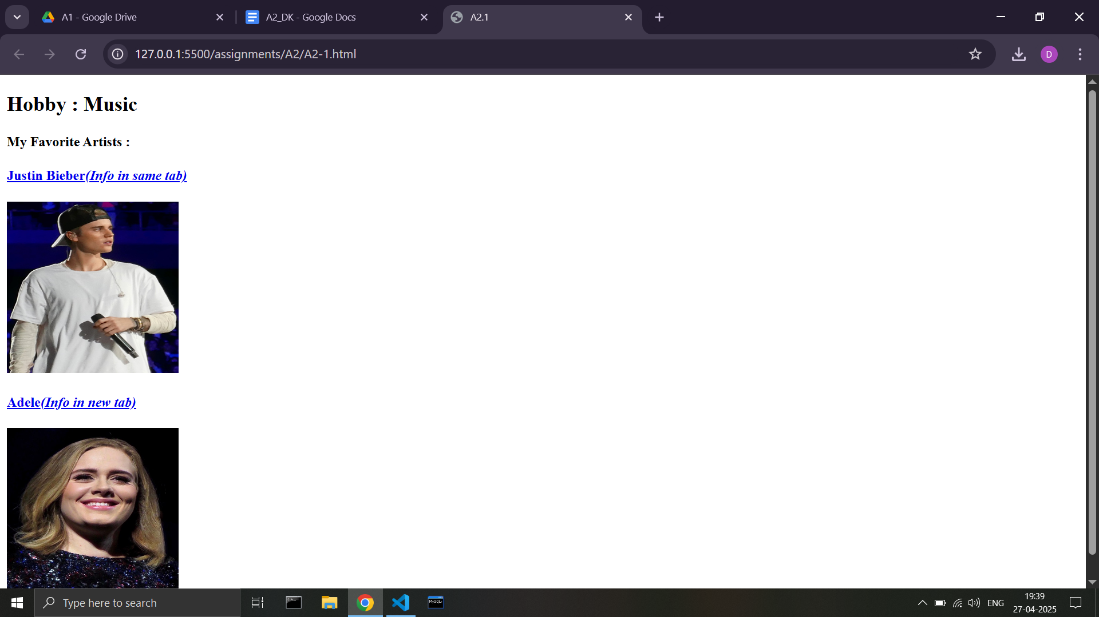

**Code -**

**<html>**

**<head>**

**<title>A2.1</title>**

**</head>**

**<body>**

**<h2>Hobby : Music</h2>**

**<h4>My Favorite Artists :</h4>**

**<a href="https://en.wikipedia.org/wiki/Justin_Bieber">**

**<h4>Justin Bieber<i>(Info in same tab)</i></h4>**

**<img src="https://i.postimg.cc/MKrST6kQ/Justin-Bieber-in-2015.jpg" alt="image not found" height="200px" width="200px">**

**</a><br>**

**<a href="https://en.wikipedia.org/wiki/Adele" target="_blank">**

**<h4>Adele<i>(Info in new tab)</i></h4>**

**<img src="https://i.postimg.cc/JhxMcbDs/Adele-2016.jpg" alt="image not found" height="200px" width="200px">**

**</a>**

**</body>**

**</html>**

1. **Output -**

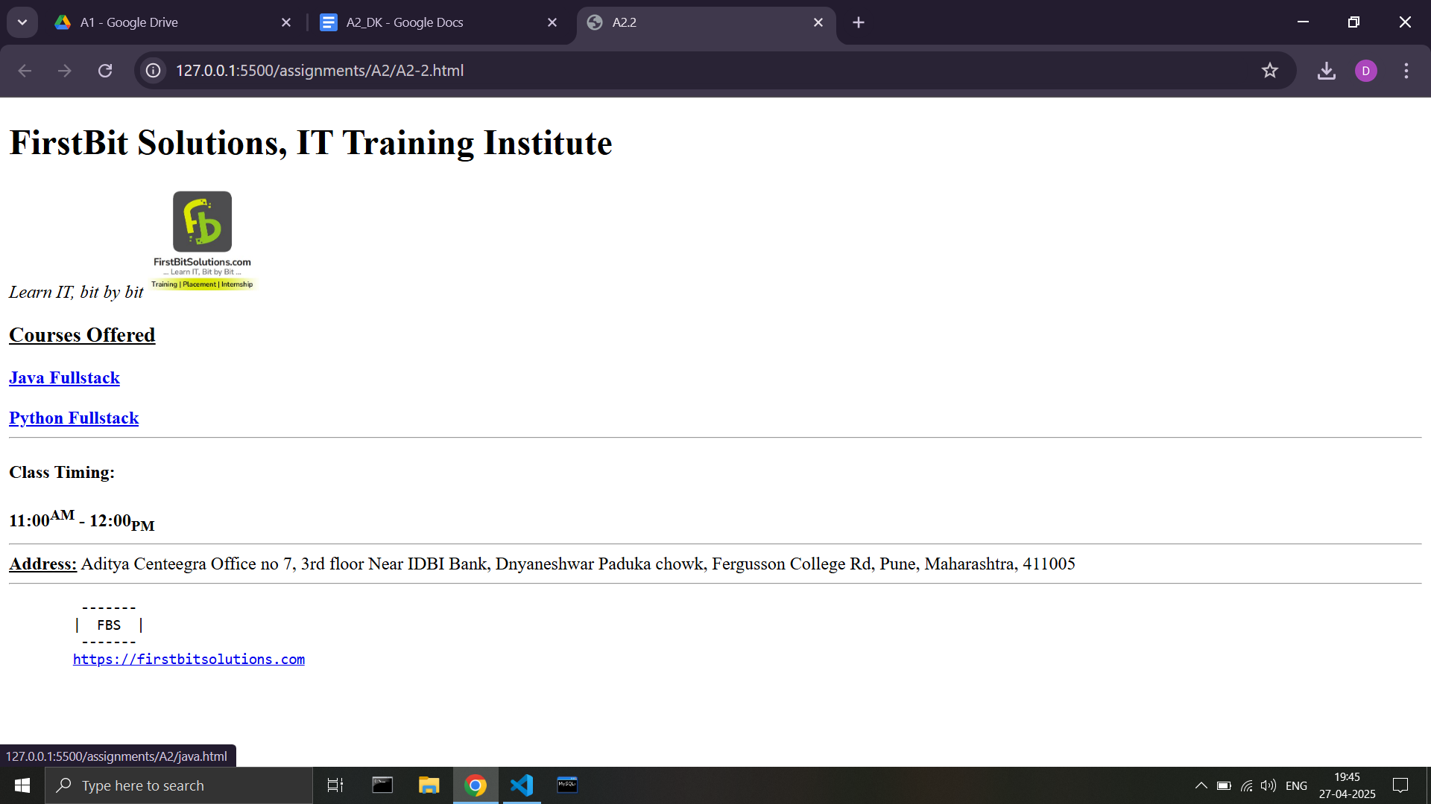

**Code -**

**<html>**

**<head>**

**<title>A2.2</title>**

**</head>**

**<body>**

**<h1>FirstBit Solutions, IT Training Institute</h1>**

**<i>Learn IT, bit by bit</i>**

**<img src="https://i.postimg.cc/9FLzZYBS/logo.jpg" height="100px" width="100px">**

**<h3><u>Courses Offered</u></h3>**

**<a href="java.html" target="_blank"><b>Java Fullstack</b></a>**

**<br><br>**

**<a href="python.html" target="_blank"><b>Python Fullstack</b></a>**

**<hr>**

**<h4>Class Timing:</h4>**

**<b>11:00<sup>AM</sup> - 12:00<sub>PM</sub></b>**

**<hr>**

**<b><u>Address:</u></b>**

**Aditya Centeegra Office no 7, 3rd floor Near IDBI Bank, Dnyaneshwar Paduka chowk, Fergusson College Rd, Pune, Maharashtra, 411005**

**<hr>**

**<pre>**

**-------**

**| FBS |**

**-------**

**<a href="https://firstbitsolutions.com" target="_blank">https://firstbitsolutions.com</a>**

**</pre>**

**</body>**

**</html>**

**Java Fullstack page -**

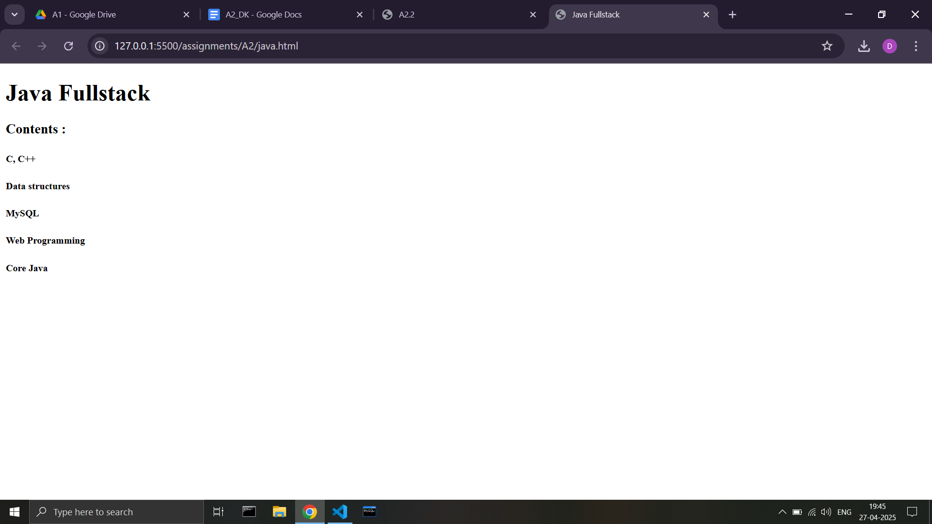

**Code -**

**<html>**

**<head>**

**<title>Java Fullstack</title>**

**</head>**

**<body>**

**<h1>Java Fullstack</h1>**

**<h3>Contents : </h3>**

**<h5>C, C++</h5>**

**<h5>Data structures</h5>**

**<h5>MySQL</h5>**

**<h5>Web Programming</h5>**

**<h5>Core Java</h5>**

**</body>**

**</html>**

**Python Fullstack page -**

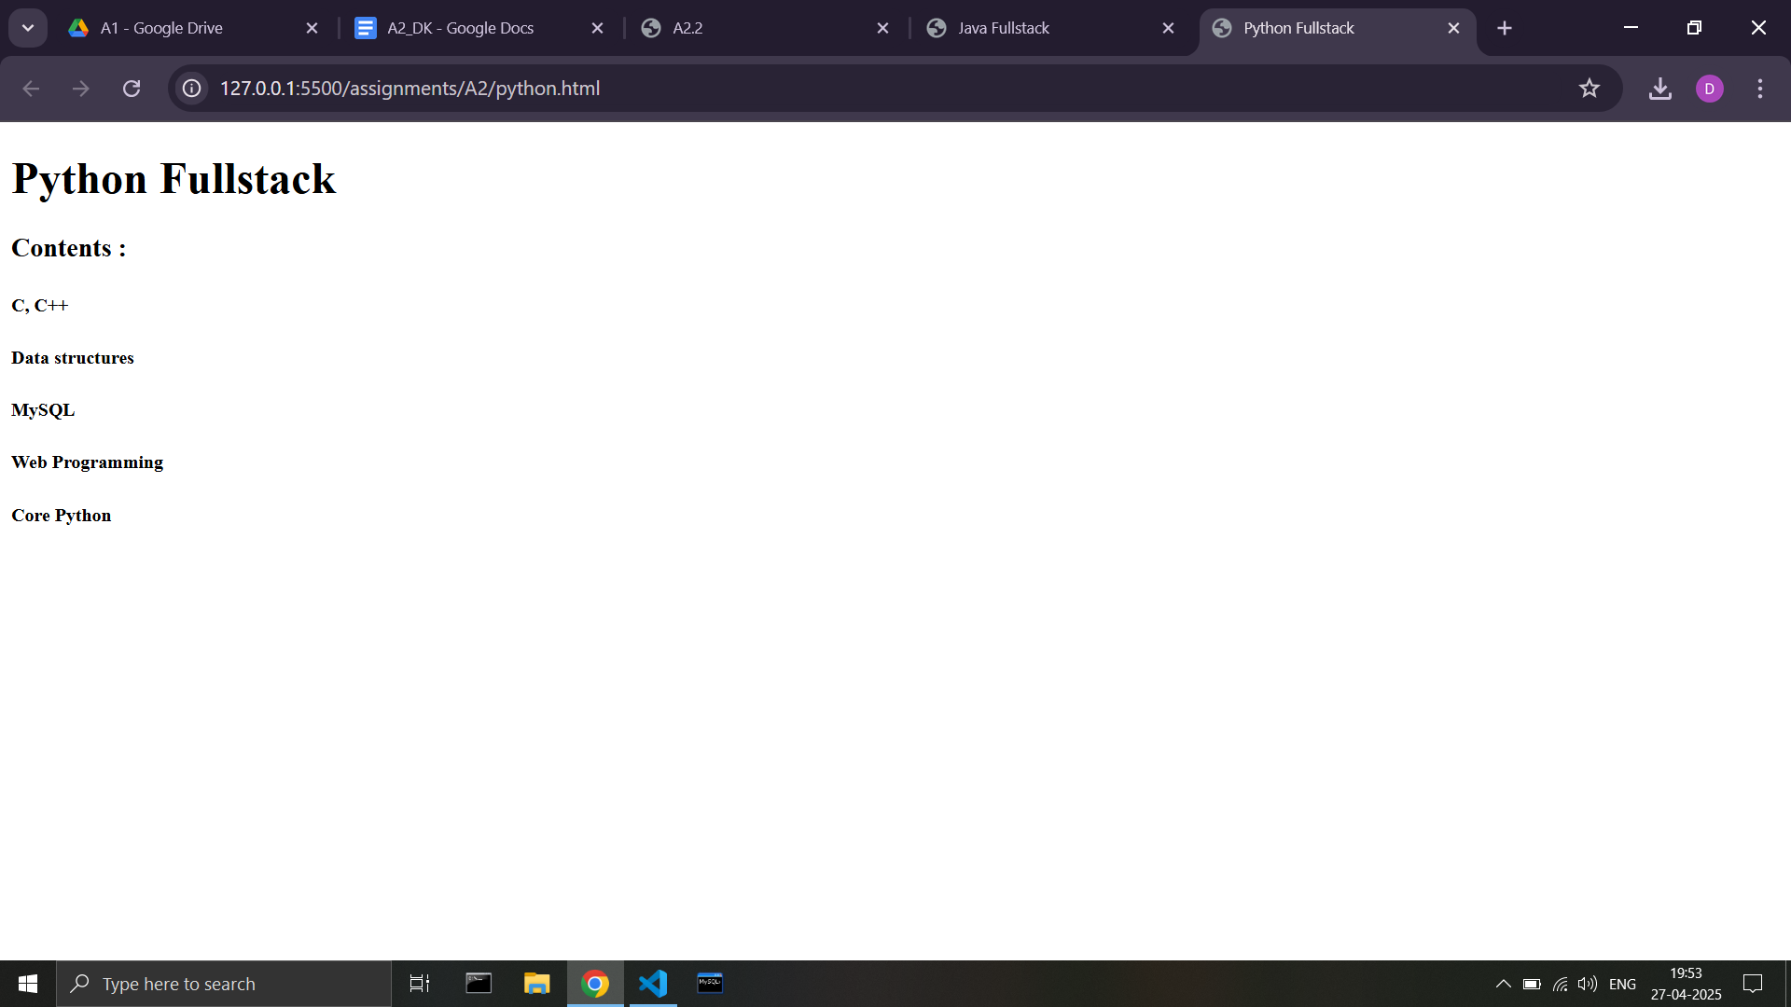

**Code -**

**<html>**

**<head>**

**<title>Python Fullstack</title>**

**</head>**

**<body>**

**<h1>Python Fullstack</h1>**

**<h3>Contents : </h3>**

**<h5>C, C++</h5>**

**<h5>Data structures</h5>**

**<h5>MySQL</h5>**

**<h5>Web Programming</h5>**

**<h5>Core Python</h5>**

**</body>**

**</html>**